
American International University- Bangladesh (AIUB) Faculty of Engineering (FE)

Course Name: | DATA COMMUNICATION | Course Code: | COE3103
Semester: | Spring 2024-25 | Section: | L
Faculty: | DR. AMIRUL ISLAM | Group: | 08
Experiment No: | 07
Experiment Name: | Study of Amplitude Modulator and Demodulator using Simulink

Submitted by (NAME): | HOSSAIN MOHAMMAD SAMI | Student ID: | 23-51354-1
Group Members |  | Name | ID
 | 1. | MD. MIRAN HOSSAIN | 22-46175-1
 | 2. | FAHMIDA RAHMAN | 22-48483-3
 | 3. | MOHSIN IBNA HOSSAIN | 23-50194-1
 | 4. | MD. YEAHYEA JAM | 23-50187-1
 | 5. | HOSSAIN MOHAMMAD SAMI | 23-51354-1

Performance Date: | 05/05/2025 | Due Date: | 12/05/2025
Marking Rubrics (to be filled by Lab Instructor)
Category | Proficient [6] | Good [4] | Acceptable [2] | Unacceptable [1] | Secured Marks
Theoretical Background, Methods & procedures sections | All information, measures and variables are provided and  explained. | All Information provided is sufficient, but more explanation is  needed. | Most information is correct, but some information may be  missing or inaccurate. | Much information is missing and/or inaccurate.
Results | All of the criteria are met; results are described clearly and accurately; | Most criteria are met, but there may be some lack of clarity and/or incorrect information. | Experimental results don’t match exactly with the theoretical values and/or analysis  is unclear. | Experimental results are missing or incorrect;
Discussion | Demonstrates thorough and sophisticated understanding.  Conclusions drawn are appropriate for  analyses; | Hypotheses are clearly stated, but some concluding statements not supported by data or data not well  integrated. | Some hypotheses missing or misstated; conclusions not supported by data. | Conclusions don’t match hypotheses, not supported by data; no integration of data from different sources.
General formatting | Title page, placement of figures and figure captions, and other  formatting issues all correct. | Minor errors in formatting. | Major errors and/or missing information. | Not proper style in text.
Writing & organization | Writing is strong and easy to understand; ideas are fully elaborated and connected; effective transitions between sentences; no  typographic, spelling, or grammatical errors. | Writing is clear and easy to understand; ideas are connected; effective transitions between sentences; minor typographic, spelling, or grammatical errors. | Most of the required criteria are met, but some lack of clarity, typographic, spelling, or grammatical errors are present. | Very unclear, many errors.
Comments: |  |  |  | Total Marks (Out of 30):

Title
Study of Amplitude Modulator and Demodulator using Simulink
Abstract
This experiment is designed to-
1.To understand the use of Simulink for AM modulation.
2.To develop understanding of AM demodulation.
Introduction
Amplitude modulation (AM) is a one of the conventional technique used to transmit message signals using a carrier wave. The amplitude or strength of the high frequency carrier wave is modified in accordance with amplitude of the message signal.
- AM Modulation:
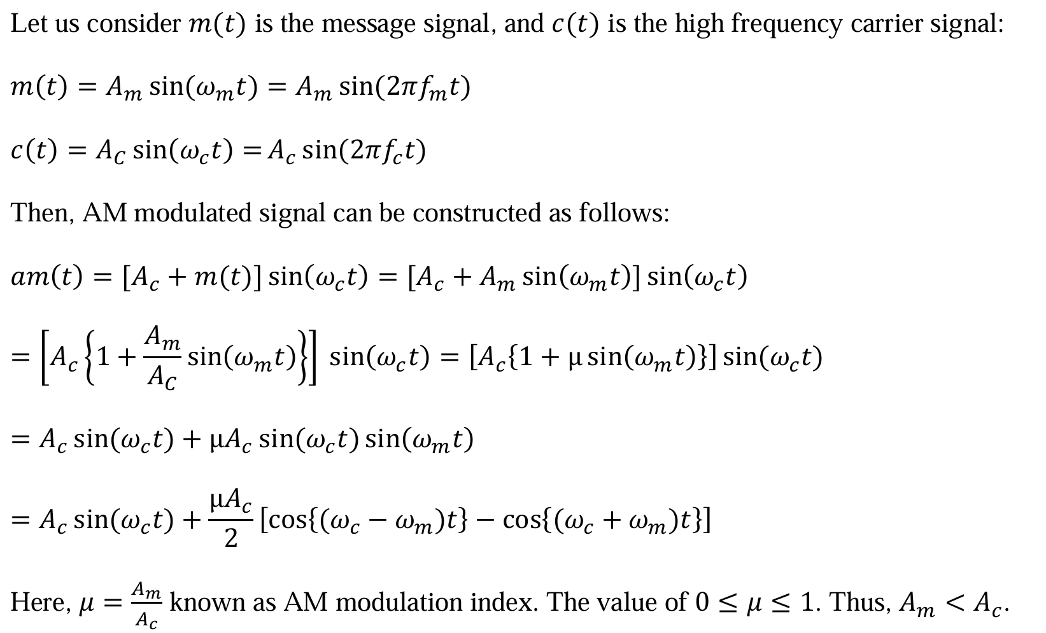
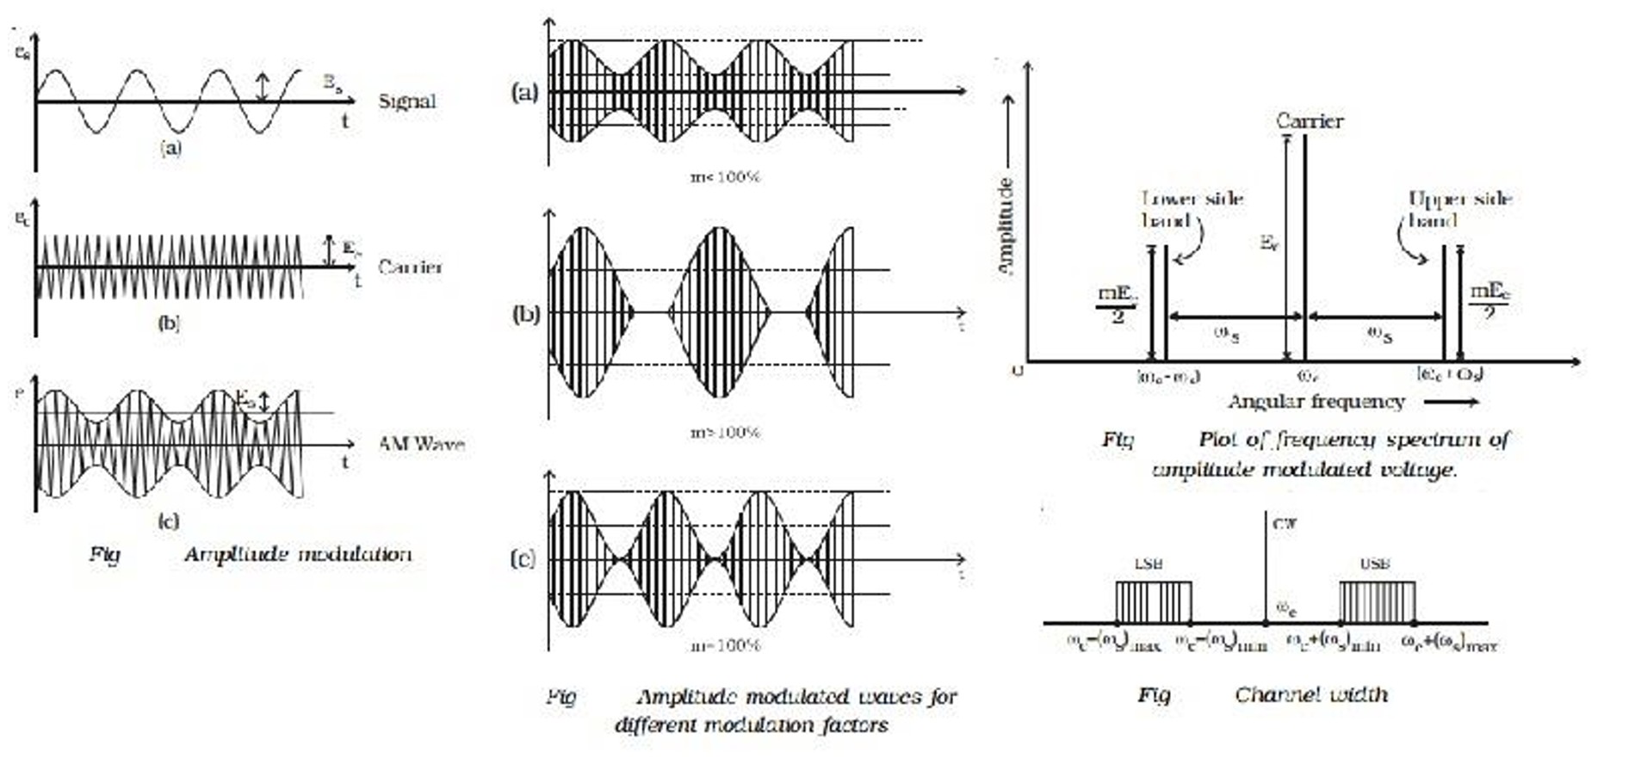
Fig1: AM modulated signal in time and frequency domain.
- AM Demodulation:
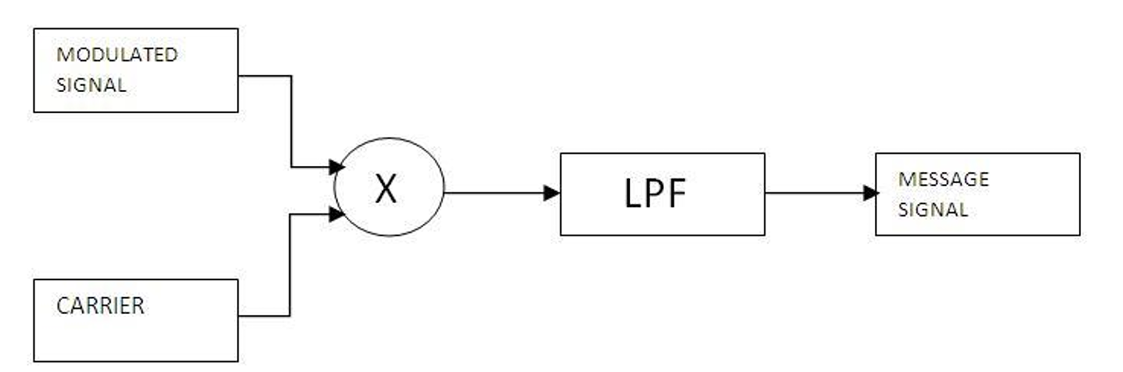
Fig2: AM demodulation process.
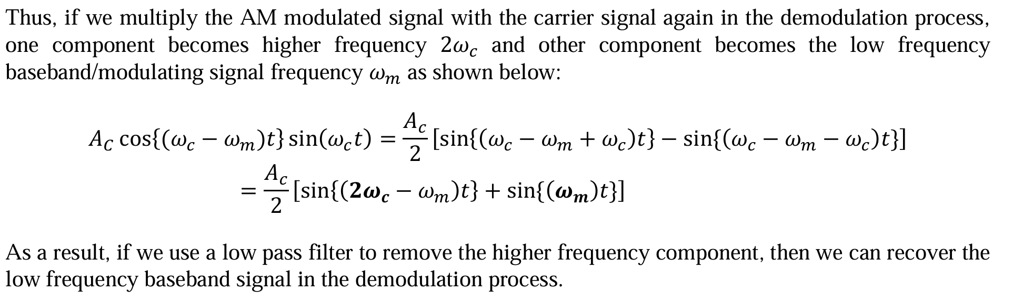
Block Diagram
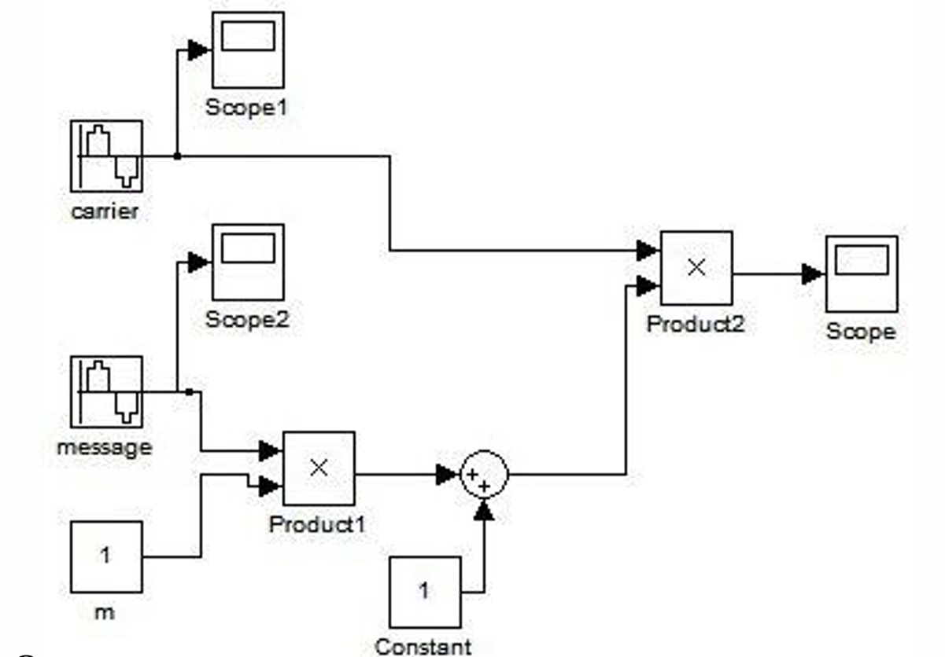
Fig3: AM Generation using Simulink – Block Diagram
Results and Discussion
A signal ‘m(t) = (2*sin(2*pi*4*t)+3*cos(2*pi*6*t))’. Apply amplitude modulation (AM) on the given signal with carrier signal ‘c(t) = cos(2*pi*50*t)’, and then do demodulation to recover the original message signal m(t).
Simulink – Block Diagram
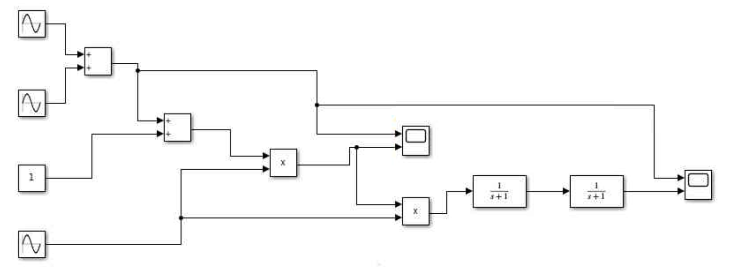
Fig4: AM Modulation & Demodulation using Simulink

Result and Discussion:
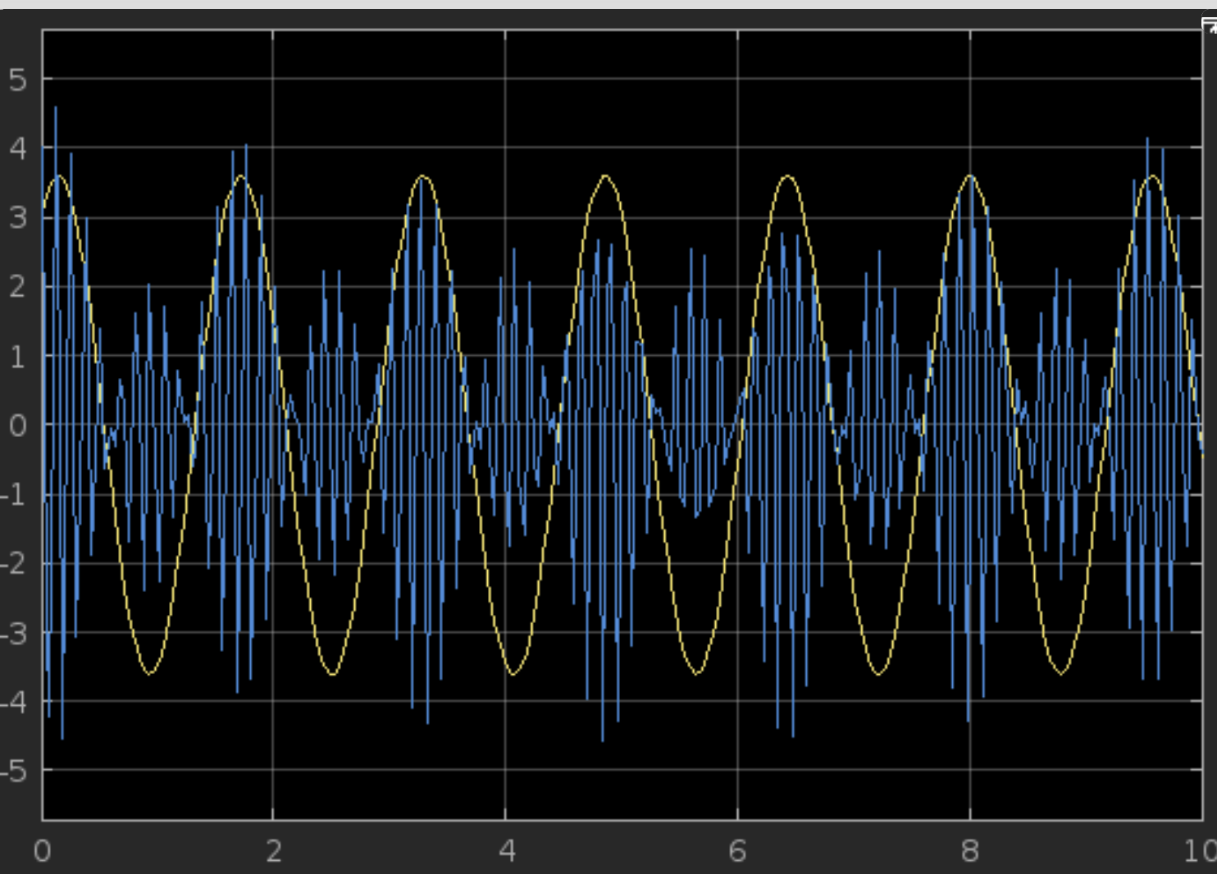
Fig5: AM Modulation signal
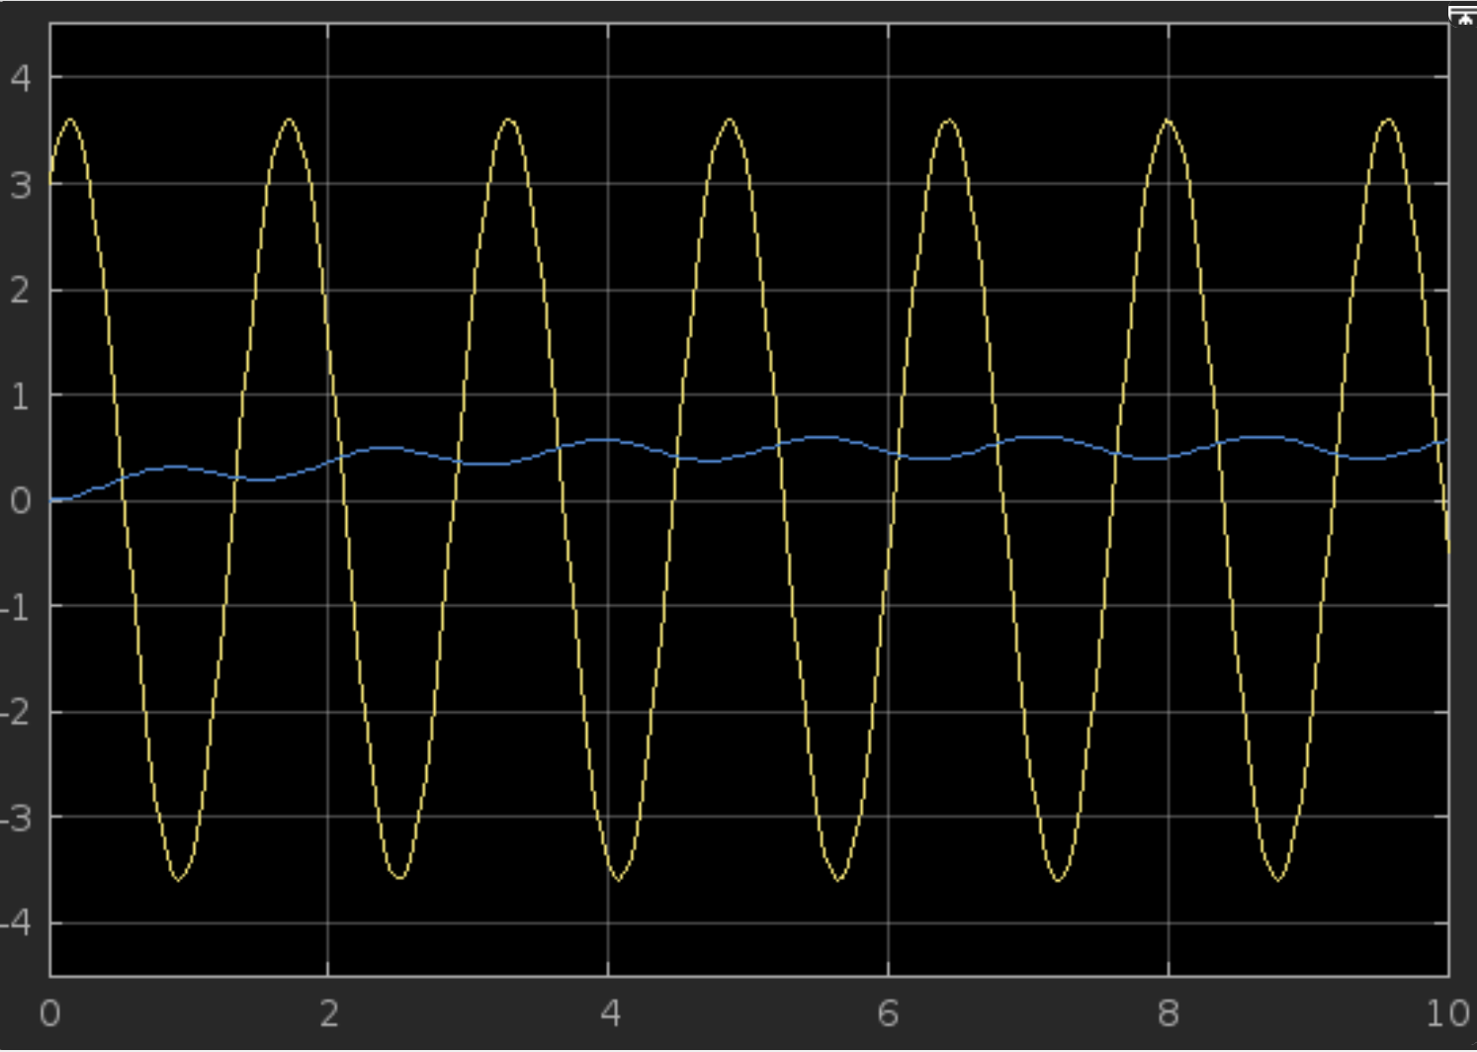
Fig6: AM Demodulation signal
In this experiment, we explored the simulation of amplitude modulation (AM) and demodulation using Simulink. The message signal m(t) = (2*sin(2*pi*4*t) +3*cos(2*pi*6*t)), was successfully modulated using a high-frequency carrier signal c(t) = cos(2*pi*50*t). The AM modulated waveform displayed the expected envelope shape that corresponds to the amplitude variations of the original message signal. This confirmed that the modulation process was effectively implemented.
The demodulation process was carried out using an envelope detector setup in Simulink. The recovered signal closely matched the original message signal, validating the accuracy of the demodulation method. Minor distortions observed were likely due to filtering limitations or sampling rate constraints, which are common in simulation environments.
Throughout the process, Simulink proved to be an effective tool for visually understanding and analyzing the behavior of modulated signals in both time and frequency domains. The experiment highlighted the importance of proper carrier frequency selection, filter design, and signal synchronization in the modulation-demodulation chain.

Conclusion
The experiment successfully demonstrated amplitude modulation and demodulation using Simulink. The results show that AM can efficiently transmit message signals and that demodulation can accurately retrieve the original information under ideal conditions. This simulation-based approach provided valuable insight into the fundamental principles of analog communication systems and reinforced theoretical concepts with practical visualization. Future experiments could involve noise addition and alternative modulation schemes to further deepen understanding.

